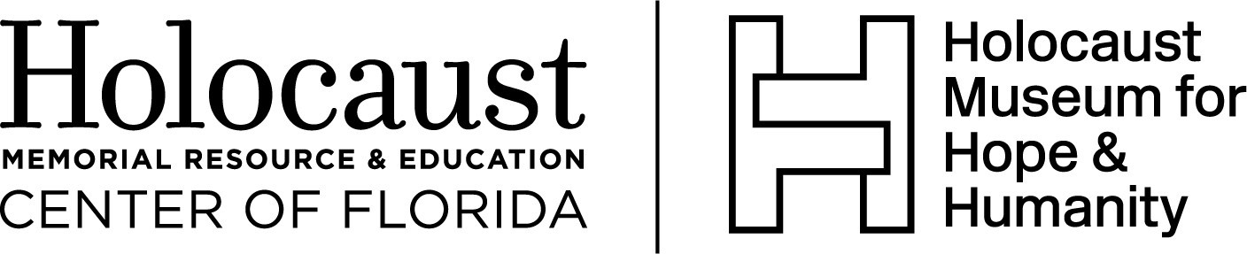

Volunteer Application
Application date: ____ / _____ / _____
Volunteer position sought (circle one or more below)

- Sunday volunteer (12-4 p.m.)

- Saturday volunteer (12-4 p.m.)

- Weekday volunteer (Monday-Thursday 10 a.m. – 4 p.m. and Friday 10 a.m. – 1 p.m.)

- Episodic (I prefer to volunteer at special events or for special projects on an as-needed basis.)

- Other, please explain:

Contact Information:
Full name _________________________________________________________________
Home address __________________________________________________________________
Primary phone _____ Secondary phone
Email address
Education:
Highest level of education
Employment:
Current employer, if applicable: _____
Position/Title
Dates of employment (starting, ending)
Address
Would you like us to keep your employer informed of your volunteer service and achievement?
No ____ Yes ____
Please provide contact name and email, if ‘Yes’ _________________________________________

Special training, skills, hobbies:

Groups, clubs, organizational memberships, etc.:

Please describe your prior volunteer experience (include organization names, dates of service):

Why do you want to volunteer at the Holocaust Center? [or: What do you want to gain from this volunteer experience?]

Have you ever been convicted of a crime? If yes, please explain the nature of the crime and the date of the conviction and disposition. Conviction of a crime is not an automatic disqualification for volunteer work.
_________ ___________________________________________________________________

How did you learn about volunteer opportunities at the Holocaust Center?

References:
Please list two people who know you well and can attest to your character, skills, and dependability (not family members unless under age 18). This can include your current or last employer.

- Name/Organization
  - Relationship to you:
  - Phone:
  - Length of relationship:
- Name/Organization
  - Relationship to you:
  - Phone:
  - Length of relationship:

EMERGENCY CONTACT
In the case of an emergency, please notify:
Name
Relationship to you
Primary phone Alternative phone
Please read the following carefully before signing this application:
I understand that this is an application for and not a commitment or promise of a volunteer opportunity.
I certify that I have and will answer all questions to the best of my ability. I understand that information contained on my application will be verified by the Holocaust Memorial Resource and Education Center of Florida. I understand that misrepresentations or omissions may be cause for my immediate rejection as an applicant for a volunteer position with the Holocaust Memorial Resource and Education Center of Florida and/or my termination as a volunteer.

Printed name
Signature
Date

Please return this completed application to the Holocaust Center via email: info@holocaustedu.org or via standard mail: 851 N. Maitland Ave., Maitland, FL 32751.

